Volatility correlation: GBPUSD and USDCAD
Method 25 / daily |log returns| / rho_vol / Alpari D1 full available history (realized deferred)

Study setup
Logical pair: GBPUSD , USDCAD
Broker symbols: GBPUSD_i , USDCAD_i
Snapshot: 2026-11-03_majors_alpari_D1
Timeframe: D1
Matched return window: 1999-01-05 to 2026-11-02 (UTC bar dates)
Matched return count n: 7205
Dropped unfinished last bar dated 2026-11-03 UTC after a tick-volume check against the prior complete day.
Statistic: rho_vol = Corr(|log return_L|, |log return_R|)
rho_realized: not computed (no intraday buckets in this snapshot)
Complete matched rows (Excel): GBPUSD-USDCAD_Vol_D1.xlsx
Complete matched rows (HTML table): GBPUSD-USDCAD_Vol_D1_data.html

Method carried forward
Volatility correlation rho_vol = Corr(|x_t|, |y_t|) measures whether absolute daily log returns of close move together in size, regardless of sign. Quotes are not inverted. Same-sample signed Pearson r is a side check. The formula sheet also defines within-day realized correlation rho_realized,d from intraday buckets; this v001 uses the Alpari D1 snapshot only, so rho_realized is not computed (no intraday buckets). This is not causation and not a trading signal.

Results (headline)
rho_vol: 0.344748
Pearson r (signed): -0.456462
mean |GBPUSD|: 0.00412099
mean |USDCAD|: 0.00373293
rho_realized: n/a (D1-only snapshot)

Conclusion
Headline rho_vol for GBPUSD and USDCAD: 0.3447. Signed Pearson r = -0.4565. Mean |return|: 0.004121 (GBPUSD), 0.003733 (USDCAD). rho_realized not computed (D1 snapshot has no intraday buckets). This is absolute-move co-movement, not a trading signal.

Charts
Daily closes

Daily log returns

Absolute returns scatter
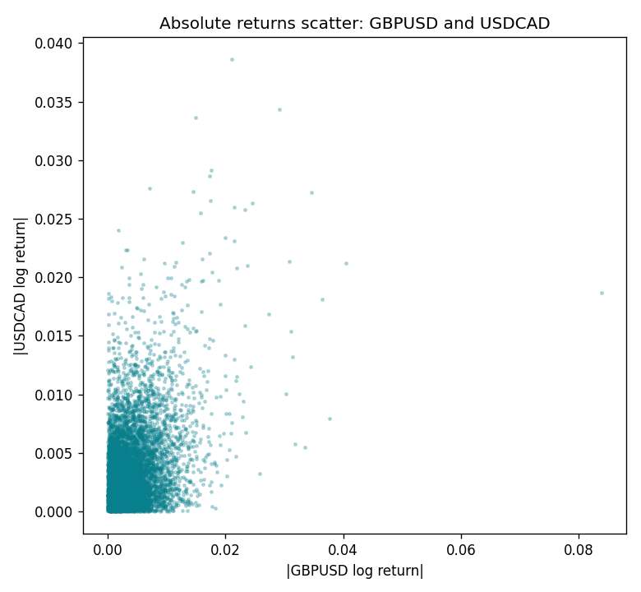

Data report
Matched rows are in the sibling Excel workbook named GBPUSD-USDCAD_Vol_D1.xlsx. Embedding all rows as a Word table is impractical; this file holds column summaries and the first and last 15 matched rows.
Columns: time, GBPUSD_open, USDCAD_open, GBPUSD_high, USDCAD_high, GBPUSD_low, USDCAD_low, GBPUSD_close, USDCAD_close, GBPUSD_tick_volume, USDCAD_tick_volume, GBPUSD_spread, USDCAD_spread, GBPUSD_real_volume, USDCAD_real_volume, GBPUSD_log_return, USDCAD_log_return, GBPUSD_abs_return, USDCAD_abs_return
Column summaries (matched calculation rows)
column | count | mean | std | min | 25% | 50% | 75% | max
GBPUSD_open | 7205 | 1.5161639 | 0.2182756 | 1.06854 | 1.32505 | 1.51142 | 1.63205 | 2.1066
USDCAD_open | 7205 | 1.2670469 | 0.16900802 | 0.9168 | 1.119 | 1.29857 | 1.3723 | 1.6183
GBPUSD_high | 7205 | 1.5224596 | 0.21884187 | 1.08366 | 1.32981 | 1.5182 | 1.6384 | 2.1161
USDCAD_high | 7205 | 1.2719479 | 0.16896591 | 0.9336 | 1.1234 | 1.30394 | 1.3769 | 1.619
GBPUSD_low | 7205 | 1.5098441 | 0.21750249 | 1.03518 | 1.31956 | 1.50336 | 1.62444 | 2.0983
USDCAD_low | 7205 | 1.2624879 | 0.16904619 | 0.9056 | 1.1144 | 1.29361 | 1.36793 | 1.6102
GBPUSD_close | 7205 | 1.5162333 | 0.21823062 | 1.06879 | 1.3252 | 1.5114 | 1.6322 | 2.1065
USDCAD_close | 7205 | 1.2670655 | 0.16898286 | 0.916 | 1.11851 | 1.29871 | 1.37253 | 1.6137
GBPUSD_tick_volume | 7205 | 94776.836 | 153518.92 | 62 | 9986 | 52867 | 91739 | 1273370
USDCAD_tick_volume | 7205 | 80835.261 | 147176.39 | 37 | 5509 | 40849 | 71515 | 1410818
GBPUSD_spread | 7205 | 26.978348 | 19.192834 | 0 | 11 | 20 | 50 | 50
USDCAD_spread | 7205 | 23.508952 | 18.282466 | 0 | 9 | 17 | 40 | 60
GBPUSD_real_volume | 7205 | 3.5541156e+09 | 8.441481e+10 | 0 | 0 | 0 | 0 | 2.4038164e+12
USDCAD_real_volume | 7205 | 1.8330194e+10 | 9.6578305e+10 | 0 | 0 | 0 | 0 | 2.5751613e+12
GBPUSD_log_return | 7205 | -2.188e-05 | 0.00563988 | -0.08388241 | -0.00312535 | 3.221e-05 | 0.0031749 | 0.03112653
USDCAD_log_return | 7205 | -1.219e-05 | 0.00514402 | -0.03859748 | -0.00283601 | 4.92e-05 | 0.00272763 | 0.03436319
GBPUSD_abs_return | 7205 | 0.00412099 | 0.00385016 | 0 | 0.00144795 | 0.00314988 | 0.00568218 | 0.08388241
USDCAD_abs_return | 7205 | 0.00373293 | 0.00353899 | 0 | 0.00124511 | 0.00279907 | 0.00508676 | 0.03859748
First 15 matched rows (selected columns)
time | GBPUSD_log_return | USDCAD_log_return | GBPUSD_abs_return | USDCAD_abs_return
1999-01-05 | -0.0028966287 | -0.010131666 | 0.0028966287 | 0.010131666
1999-01-06 | -0.00060452184 | -0.0003306769 | 0.00060452184 | 0.0003306769
1999-01-07 | -0.002118709 | 0.0015202092 | 0.002118709 | 0.0015202092
1999-01-08 | -0.0058954193 | -0.0020495197 | 0.0058954193 | 0.0020495197
1999-01-11 | -0.0056851331 | -0.0035137769 | 0.0056851331 | 0.0035137769
1999-01-12 | 0.0022657001 | 0.0066194721 | 0.0022657001 | 0.0066194721
1999-01-13 | 0.0091330396 | 0.0045420214 | 0.0091330396 | 0.0045420214
1999-01-14 | 0.0019376331 | 0.0069376546 | 0.0019376331 | 0.0069376546
1999-01-15 | -0.0017558204 | -0.0056905671 | 0.0017558204 | 0.0056905671
1999-01-18 | 0.0012112405 | 0.00098344542 | 0.0012112405 | 0.00098344542
1999-01-19 | 0.0018745281 | 0.002748513 | 0.0018745281 | 0.002748513
1999-01-20 | -0.0049053846 | -0.0059646885 | 0.0049053846 | 0.0059646885
1999-01-21 | 0.0031518998 | -0.0042823796 | 0.0031518998 | 0.0042823796
1999-01-22 | 0.0024781662 | 0.0025057712 | 0.0024781662 | 0.0025057712
1999-01-25 | 0.0012066366 | 0.00085579808 | 0.0012066366 | 0.00085579808
Last 15 matched rows (selected columns)
time | GBPUSD_log_return | USDCAD_log_return | GBPUSD_abs_return | USDCAD_abs_return
2026-10-13 | 0.0036434319 | -0.0046395653 | 0.0036434319 | 0.0046395653
2026-10-14 | -0.0049164679 | 0.0015184751 | 0.0049164679 | 0.0015184751
2026-10-15 | 0.0065976411 | -0.0036101503 | 0.0065976411 | 0.0036101503
2026-10-16 | 0.0037592051 | -0.0034322068 | 0.0037592051 | 0.0034322068
2026-10-19 | -0.0017500314 | -0.0018835331 | 0.0017500314 | 0.0018835331
2026-10-20 | 0.0055923442 | -0.0037066008 | 0.0055923442 | 0.0037066008
2026-10-21 | 0.0012476328 | -0.00084691787 | 0.0012476328 | 0.00084691787
2026-10-22 | 0.00022396082 | -0.0026307268 | 0.00022396082 | 0.0026307268
2026-10-23 | -0.0021146949 | 2.85545e-05 | 0.0021146949 | 2.85545e-05
2026-10-26 | -0.0024340661 | 5.7106554e-05 | 0.0024340661 | 5.7106554e-05
2026-10-27 | -0.0023648393 | 0.0025379458 | 0.0023648393 | 0.0025379458
2026-10-28 | 0.0015771808 | -0.0038379274 | 0.0015771808 | 0.0038379274
2026-10-29 | 0.0035881935 | -0.00011436495 | 0.0035881935 | 0.00011436495
2026-10-30 | 0.0013450605 | -0.0010298736 | 0.0013450605 | 0.0010298736
2026-11-02 | 0.0010971256 | 0.00061519094 | 0.0010971256 | 0.00061519094

